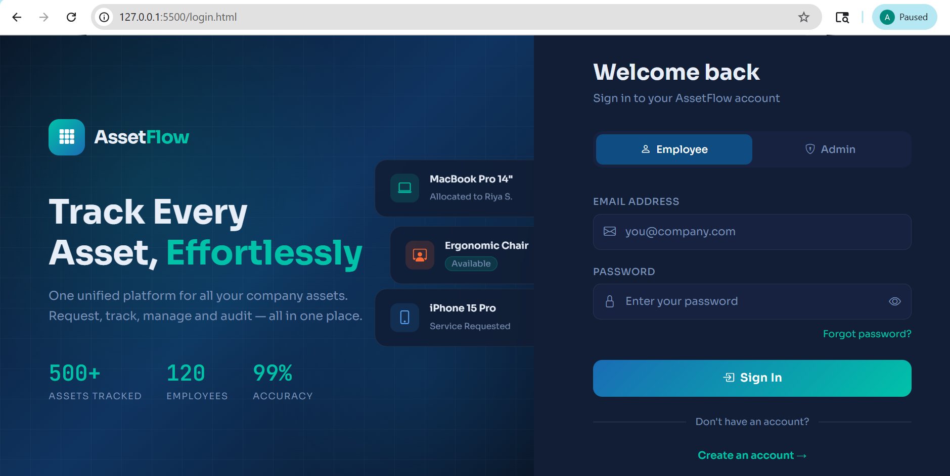
ASSET MANAGEMENT SYSTEM
- Login Page for Employee and Admin

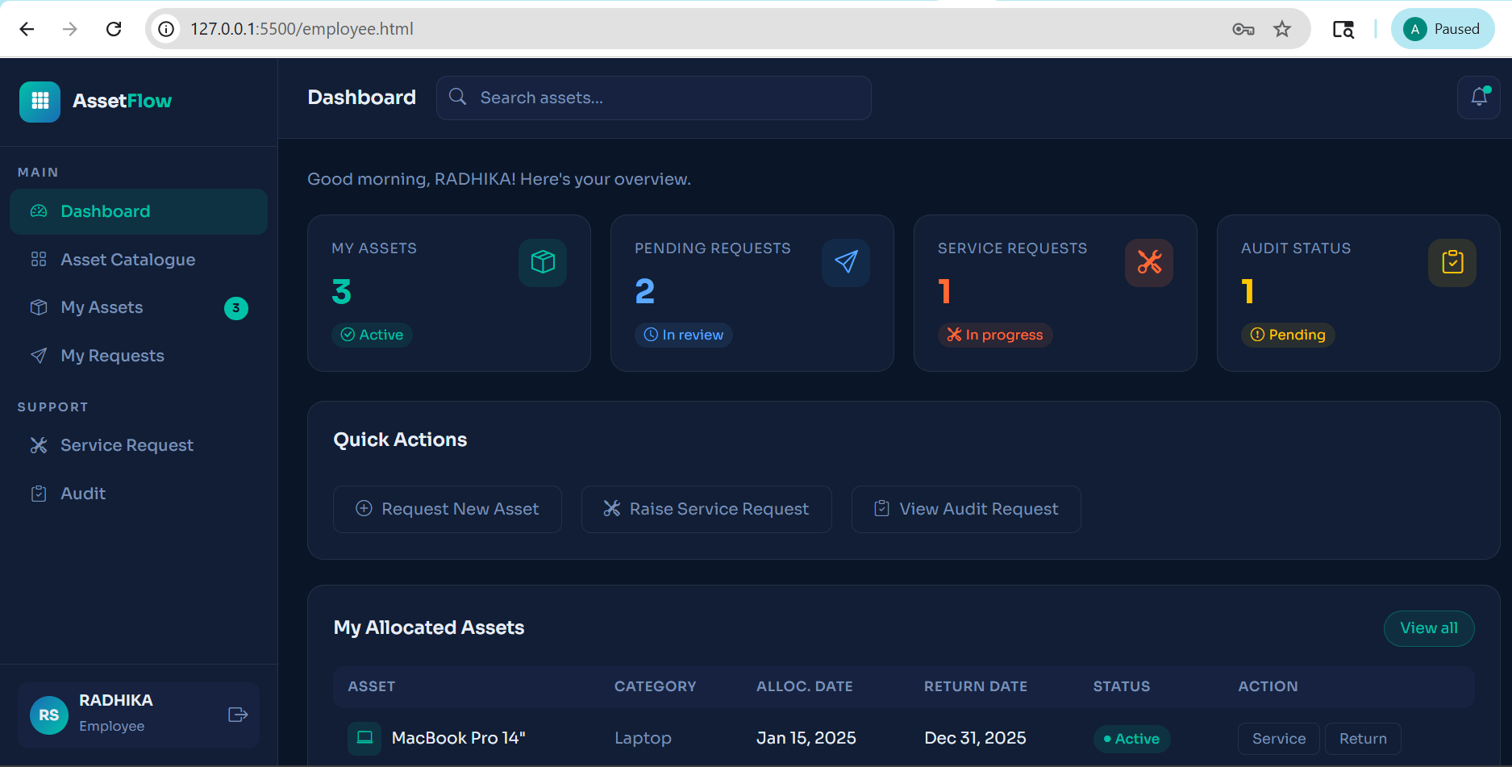
- Employee Dashboard

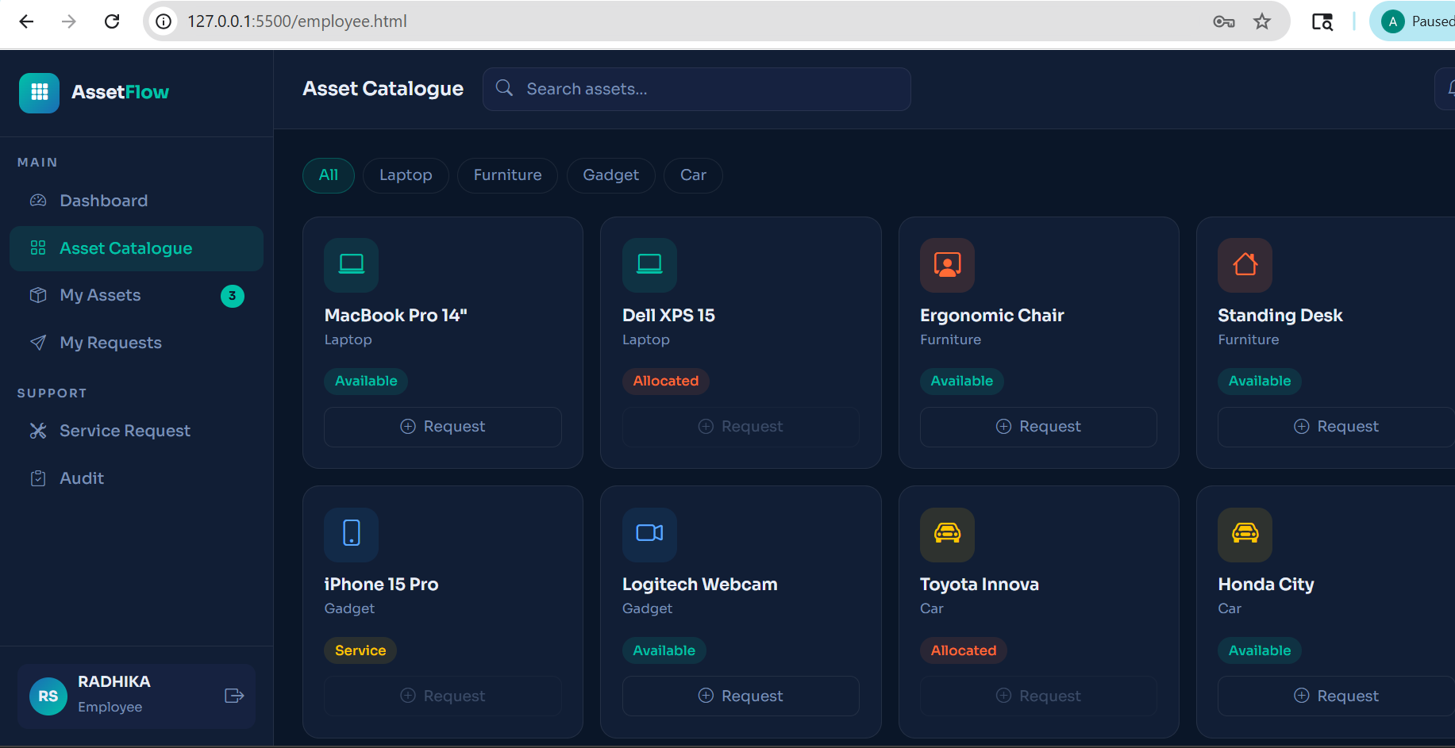
- ASSET CATALOGUE

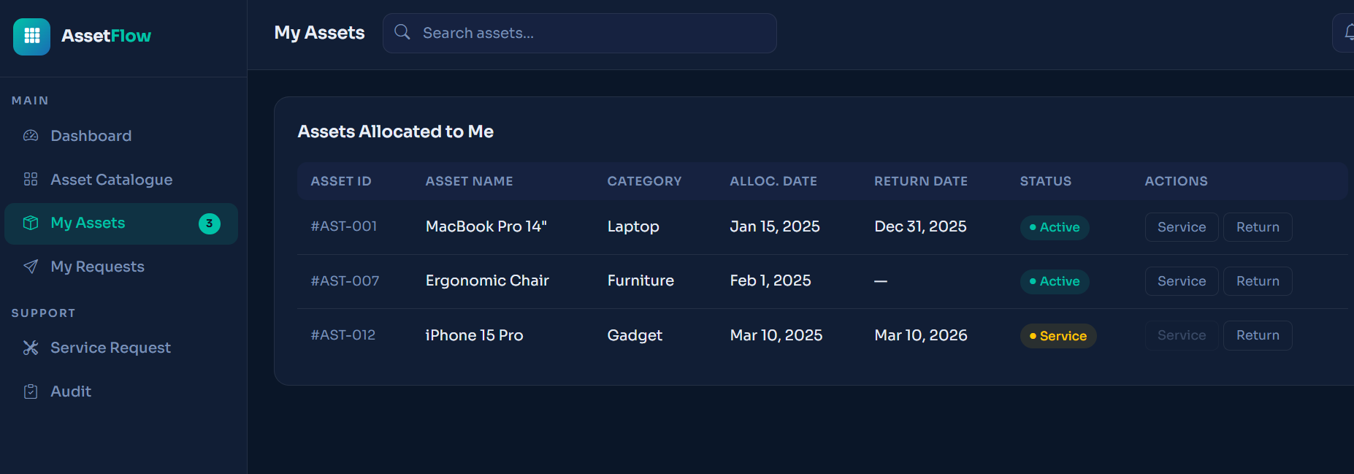
- EMPLOYEE’S ASSETS

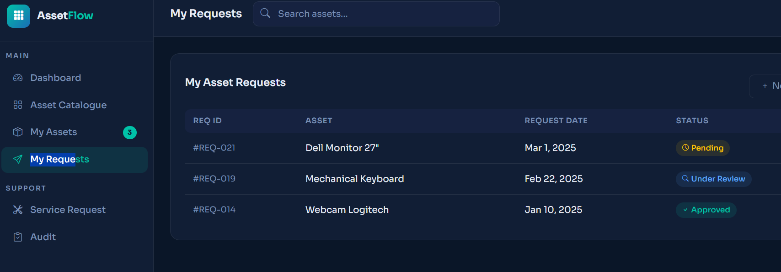
- EMPLOYEE’S ASSET REQUESTS

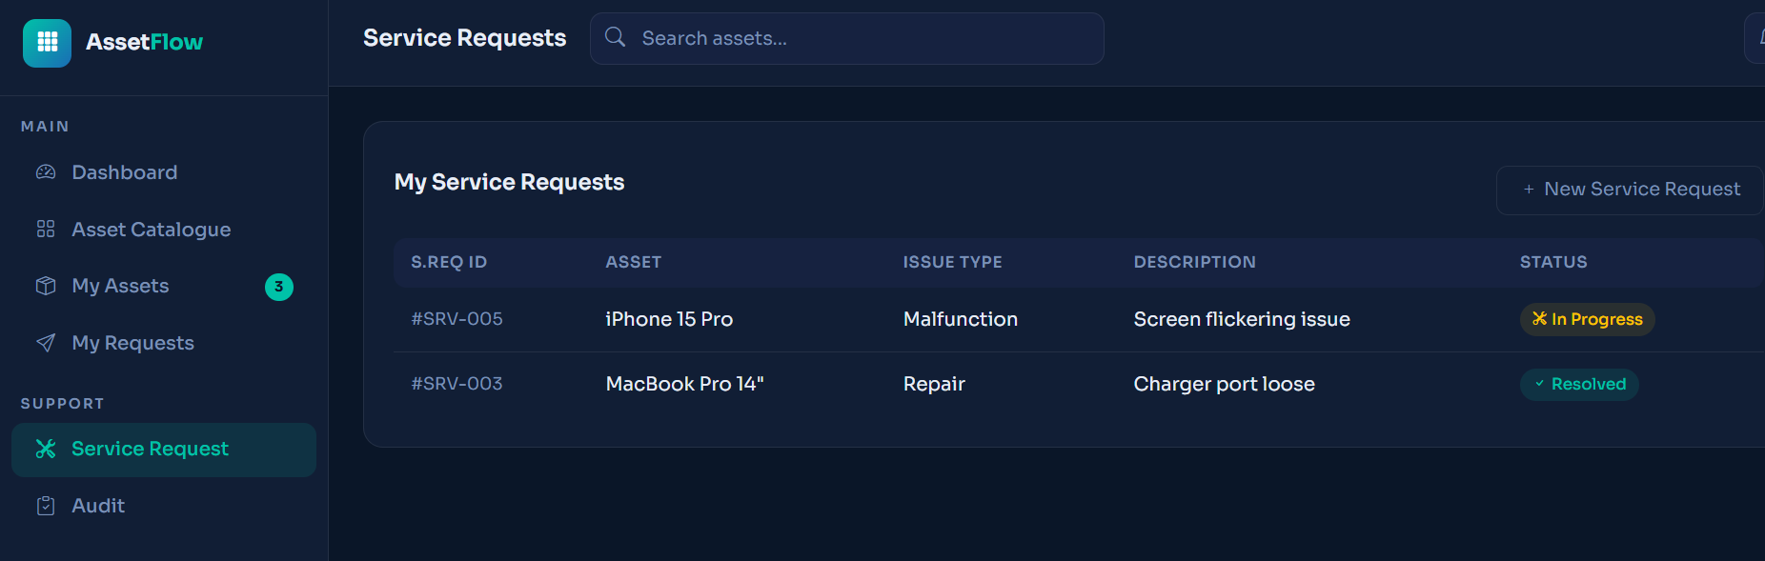
- EMPLOYEE’S SERVICE REQUESTS

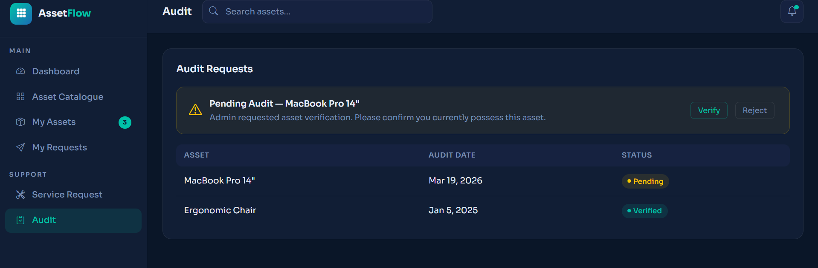
- AUDITS

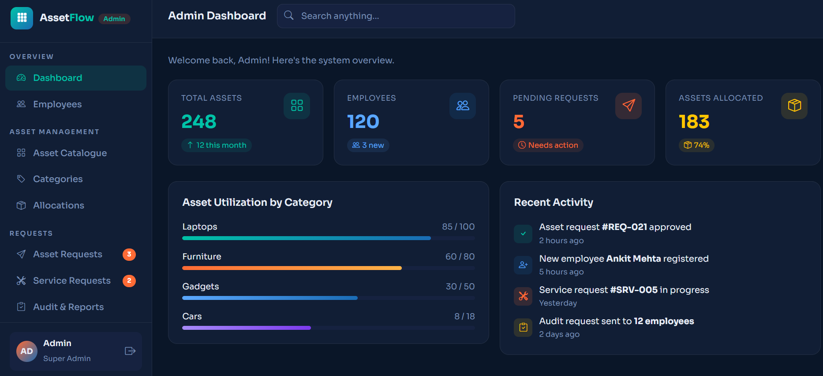
- ADMIN DASHBOARD

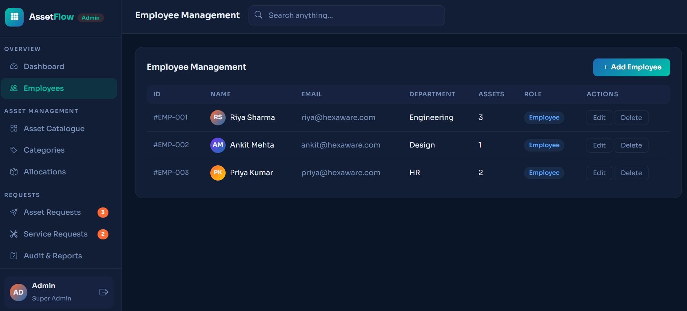
ADMIN’S EMPLOYEE DASHBOARD

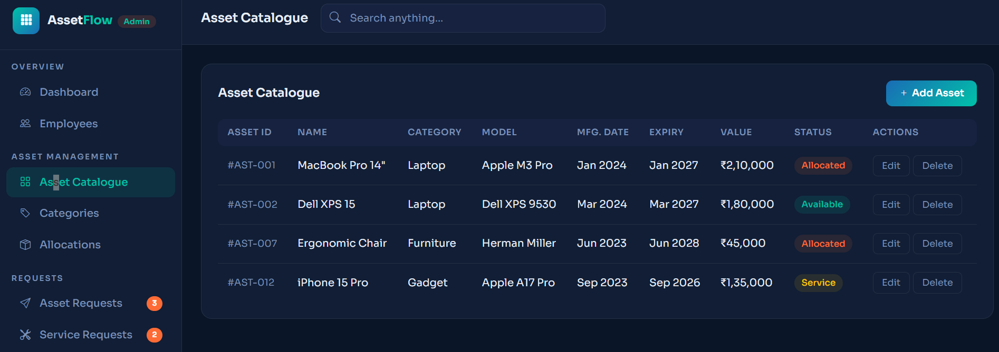
ADMIN’S ASSET CATALOGUE FOR TRACKING

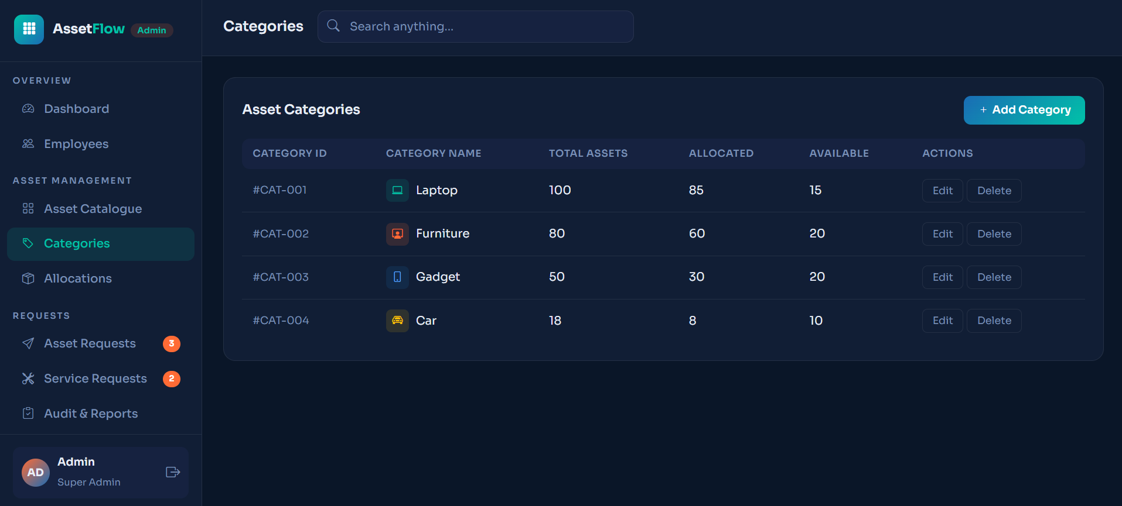
ADMIN’S ASSET CATEGORIES

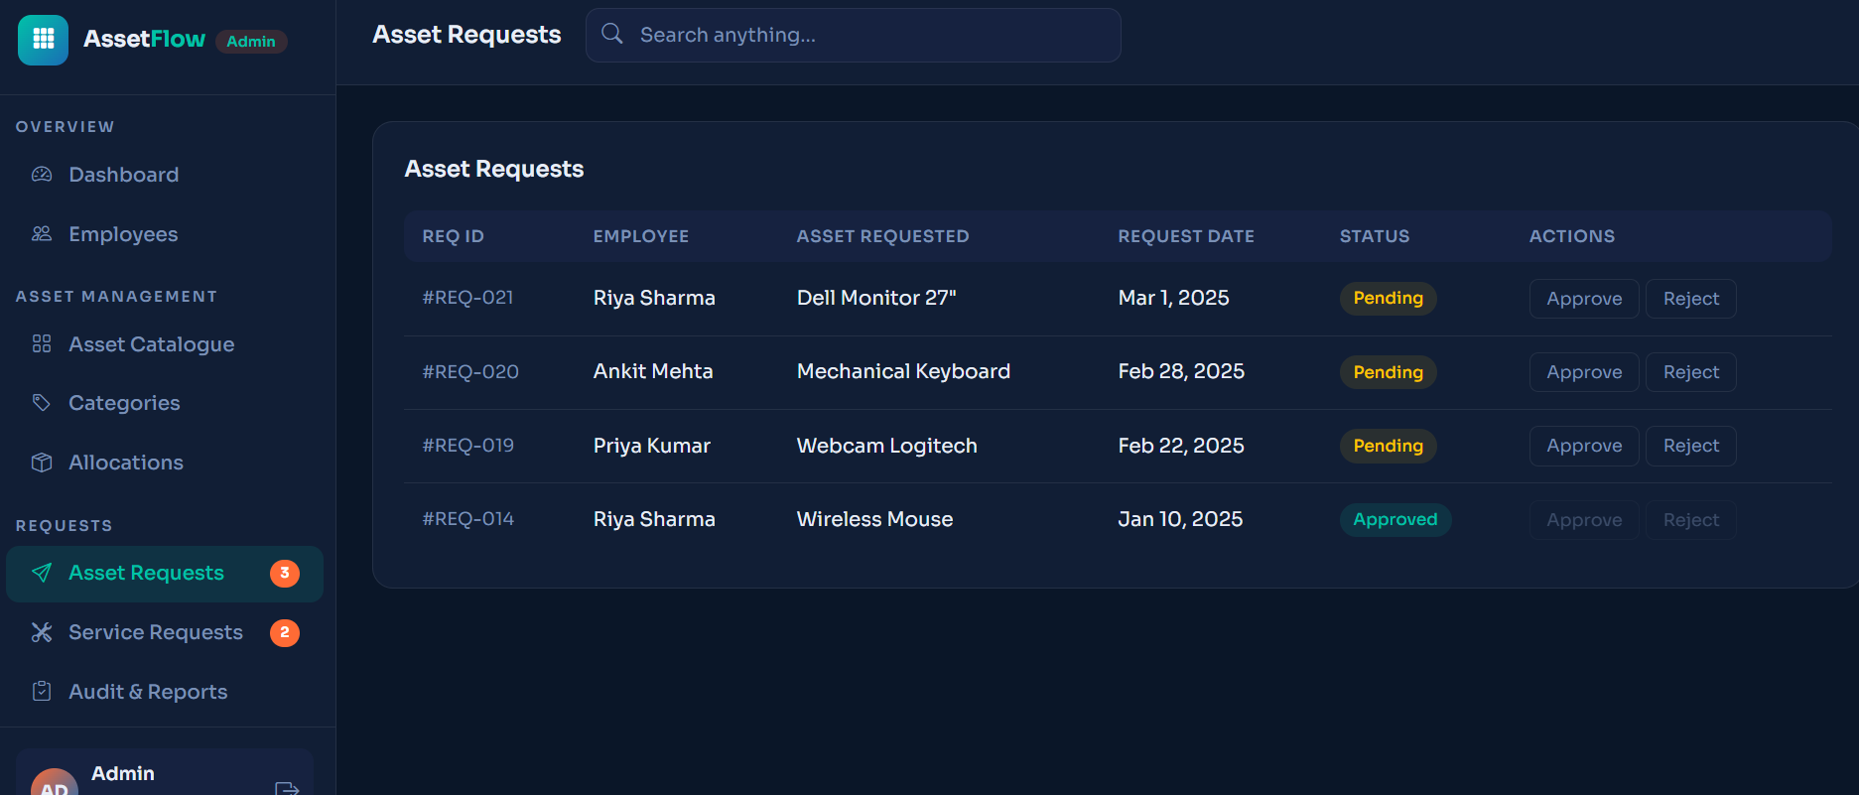
ASSET REQUESTS TO THE ADMIN

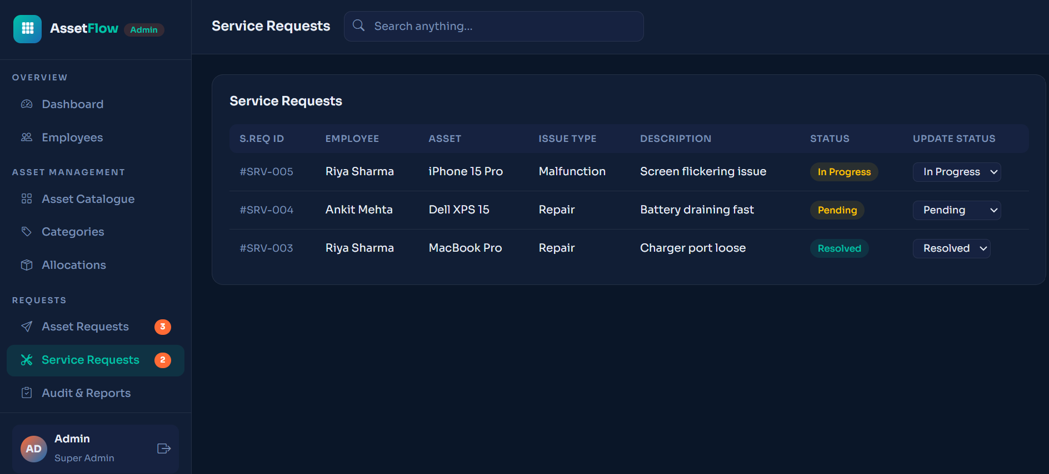
SERVICE REQUESTS FROM THE EMPLOYEE TO ADMIN

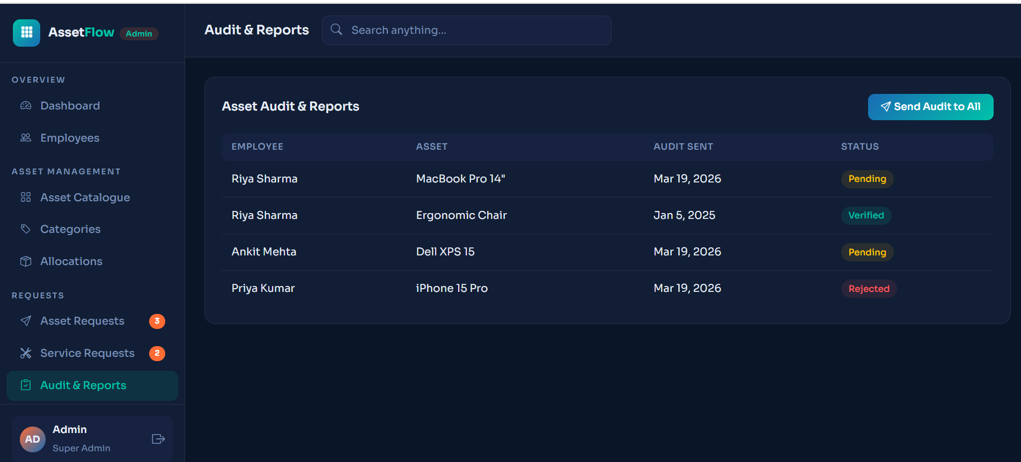
AUDITS FILED BY THE ADMIN

